**Heap Sort Output:**

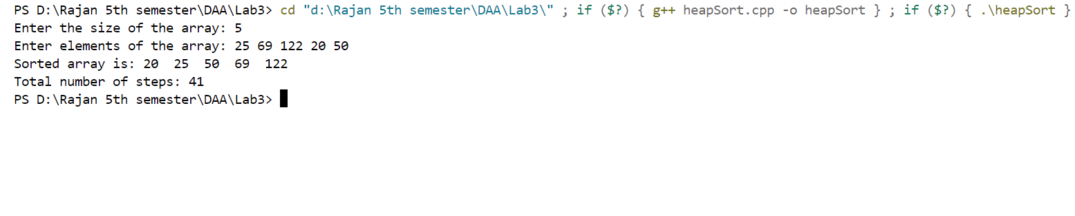

**Quick Sort Output:**

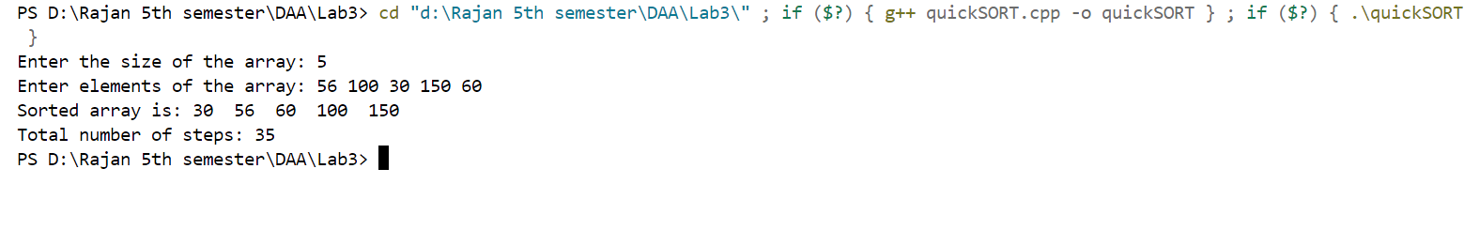

**Randomized Quick Sort Output:**

